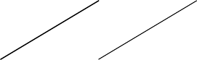159,Namdongdong-ro,Namdong-Gu,Incheon,Korea [www.samhwamix.com,](http://www.samhwamix.com/) E-Mail: [sales@samhwamix.com](mailto:sales@samhwamix.com) Tel.: +82-32-816-1470, Fax: +82-32-816-1471

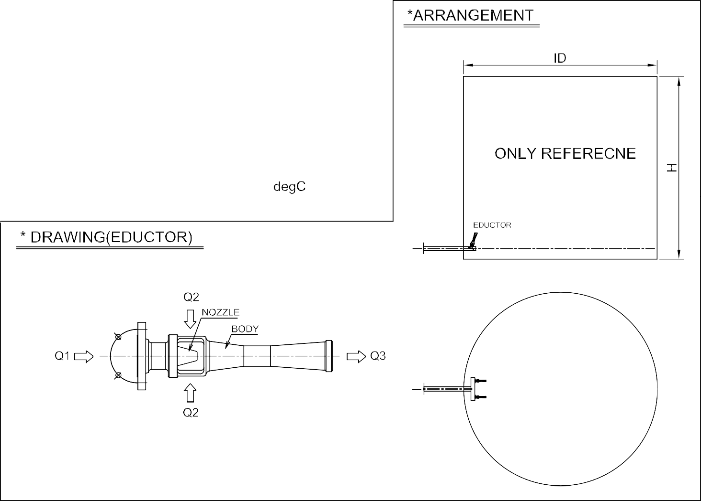



|  |  |  |  |  |  |  |  |  |
| --- | --- | --- | --- | --- | --- | --- | --- | --- |
|  |  | | |  | |  | |  |
|  | |  | |  |
|  |  | | |
|  |  | | | | | | | |
|  |  |  |  | |  | |  | |



|  |  |  |  |  |
| --- | --- | --- | --- | --- |
|  |  |  |  | |
|  | Motor Sprit |  | 15.26*12 |
|  |  |  | 2187 |
|  | 120-160 |
|  |  |
|  |  |
|  | 4-6 |
|  |  |
|  |  |
|  | 15-45 |
|  |  |
|  | 700-750 |
|  |  |
|  |  |



|  |  |  |  |
| --- | --- | --- | --- |
|  |  | | |
|  |  |  | |
|  |  | |
|  |  | |
|  |  | | |
|  |  | | |
|  |  | |  |
|  | |  |